Working mathematically in Mathematics K–6
The Working mathematically processes in the NSW Mathematics syllabus are:
- communicating
- understanding and fluency
- reasoning
- problem solving.
Students learn to work mathematically by using these processes in an interconnected way. The coordinated development of these processes results in students becoming mathematically proficient.
When students are Working mathematically it is important to help them to reflect on how they have used their thinking to solve problems. This assists students to develop ‘mathematical habits of mind’.
Students need many experiences that require them to relate their knowledge to the vocabulary and conceptual frameworks of mathematics.

Overarching Working mathematically outcome
To highlight how these processes are interrelated, in Mathematics K–6 there is one overarching Working mathematically outcome.
A student develops understanding and fluency in mathematics through:
- exploring and connecting mathematical concepts
- choosing and applying mathematical techniques to solve problems
- communicating their thinking and reasoning coherently and clearly.
The Working mathematically outcome describes the thinking and doing of mathematics. In doing so, the outcome indicates the breadth of mathematical actions that teachers need to emphasise.
The Working mathematically processes should be embedded within the concepts being taught. Embedding Working mathematically ensures students are able to fluently understand concepts and make connections to other focus areas. The mathematics focus area outcomes and content provide the knowledge and skills for students to reason about, and contexts for problem solving. The overarching Working mathematically outcome is assessed in conjunction with the mathematics content outcomes. The sophistication of Working mathematically processes develops through each stage of learning and can be observed in relation to the increase in complexity of the mathematics outcomes and content. A student's level of competence in Working mathematically can be monitored over time, for example, within Additive Relations by the choice of strategy appropriate to the task, and the use of efficient strategy for the stage of learning the student is working at.

Elaborating the processes
In becoming proficient users of mathematics, students must make connections between mathematical ideas. For example, the connections students make between spatial and numerical representations of quantity support the development of their understanding of measurement.
Working mathematically usually involves using one or more processes. Solving problems in mathematics requires understanding of concepts and relations as well as the capacity to communicate the reasoning.
Working mathematically requires students to:
- explore and connect mathematical concepts (understanding/fluency)
- choose and apply efficient techniques to solve problems (fluency/problem solving)
- communicate their thinking and reasoning coherently and clearly (communicating/reasoning).

Embedding the processes
The following processes are embedded within the outcomes and content:
- communicating
- understanding and fluency
- problem solving
- reasoning.
The nature of each Working mathematically process, and its place in the syllabus, is briefly described below.

Communicating
Students need to know mathematical content and be able to express their ideas about mathematics so that others can understand them.
The ongoing interaction with mathematical vocabulary helps to reinforce students' understanding of the words and the mathematical ideas the words represent.
Students are communicating mathematically when they describe, represent, explain and reason about mathematical situations, concepts, methods and solutions.
Students communicate through a variety of ways, such as in written, oral, graphical or symbolic form, through actions, gestures or signing. Students can be supported to communicate through the use of tools such as objects or manipulatives, text with enlarged print, audio books, braille, speech-to-text and text-to-speech applications and digital technology. Making connections between representations, known as representational fluency, supports understanding of mathematics.
Oral language and communication are key skills developed in the early years of school. Guidance on developing oral language and communication is provided in the English K–6 Syllabus, including complementary content for alternative communication forms.
Encouraging students to reflect on and discuss the strategies they use and the knowledge and skills they require assists them to learn to work mathematically. Students learn to think more deeply by:
- reflecting on what they have done
- organising their thoughts
- deciding how to express those thoughts.
They need opportunities to assess their own understanding, make connections and compare ideas.

Understanding and fluency
Understanding involves making cognitive connections between new material or experience and existing ideas.
Students demonstrate conceptual understanding when they:
- connect related ideas
- represent concepts in different ways
- identify commonalities and differences between aspects of content
- describe their thinking mathematically
- use concepts to solve new and unfamiliar problems.
Conceptual understanding supports retention. Because facts and methods learnt with understanding are connected, they are easier to remember and use, and they can be reconstructed when forgotten.
Students’ communication of their understanding reveals their mathematical fluency. Mathematical fluency encompasses students using their knowledge of mathematical concepts and strategies to solve problems. Mathematical fluency is developed when students:
- choose and use appropriate strategies
- carry out procedures flexibly, accurately and efficiently
- recall factual knowledge and concepts to solve problems
- use known facts, and reason about relationships to find solutions.

Problem solving
Some problems in mathematics can be readily solved based on experience. When confronted with a routine mathematics problem, the student is able to apply a known solution method.
In contrast, non-routine problems are problems for which the student does not immediately know a usable solution method. Questions that might start out as problematic can become routine as knowledge and experience grows. Non-routine problems require productive thinking because the student needs to invent a way to understand and solve the problem. Students need experience with both routine and non-routine mathematics problems to do this.
In becoming proficient mathematics problem-solvers, students:
- learn how to form mental representations of problems
- apply mathematical relationships
- devise novel solution methods when needed.
There is no set of generic problem-solving strategies in mathematics that students can learn to translate non-routine problems into routine problems.
Flexibility is a fundamental characteristic of problem solving in mathematics. It develops through the broadening of knowledge required for solving non-routine problems rather than just routine problems.

Reasoning
‘Reasoning is the glue that holds everything together, the lodestar that guides learning.’
Mathematics is a reasoning and creative activity. Mathematical reasoning is thinking logically about quantitative and spatial relationships. It is key to later achievement in mathematics.
As mathematical reasoning develops, students appreciate that mathematics makes sense, and can be understood. They develop an increasingly sophisticated capacity for logical thought and actions.
Reasoning has been embedded within the outcomes and content. The syllabus also identifies useful opportunities to develop mathematical reasoning in the content. In particular, the syllabus highlights reasoning about:
- quantity
- relations
- patterns
- algebra
- spatial relations
- spatial structure
- statistics.
This is not an exhaustive list of when and how students may reason about mathematical ideas and concepts. These highlights assist teachers in knowing the kind of reasoning students have the opportunity to apply.

What might reasoning look like?
Students need to become aware of how they are using mathematics to reason about familiar problems. This gives them a sense of how their developing mathematical knowledge and skills can be applied in a range of situations.

Spatial reasoning in an Early Stage 1 class
The following example of the Working mathematically process of communicating reasoning in Early Stage 1 links to the Two-dimensional spatial structure outcome: sorts, describes, names and makes two-dimensional shapes, including triangles, circles, squares and rectangles MAE-2DS-01.
Transcript from a classroom example:
A group of children is working with pattern blocks. They started working independently, making patterns, pictures, models and quite abstract designs.
One of the students notices the resemblance between the yellow blocks and the picture of a honeycomb in an opened book on the bench nearby.
We could make that [pointing] with these yellow blocks. Let’s see how big we can make it!
They begin and soon use up all the yellow blocks.
There aren’t any more yellow blocks.
Let’s use some of the red ones, or even some of the green ones to make a yellow one. These would fit, wouldn’t they?
Let’s try them.
After a short while they reflect on their work with satisfaction.
The teacher, who has been supervising groups scattered around the room, observes this achievement.
What made you think of making that design? she asks. How did you know you could use the red and the green blocks when you ran out of the yellow ones?

Without being conscious of it, these students have been using the processes of Working mathematically.
Process | Example
Classifying | The colours and shapes of the blocks.
Comparing | Noticing the similarities between the yellow blocks and the picture of the honeycomb.
Inferring | ‘We could make that with these yellow blocks.’
Estimating/predicting | ‘These would fit, wouldn’t they?’
Verifying | ‘Let’s try them.’
Spatial reasoning | ‘Let’s use some of the red ones, or even some of the green ones to make a yellow one. These would fit, wouldn’t they?’
Patterning | Tessellating the blocks.
Understanding spatial relations | How shapes fit together to form other shapes (two red shapes can form the shape of the yellow block).
Representing | The honeycomb structure modelled with pattern blocks.
Communicating/ reasoning | Responding to the teacher’s questions ‘How did you know you could use the red and the green blocks when you ran out of the yellow ones?’

Reasoning about Number in a Stage 1 class
The following is an example of part of a lesson from a primary classroom. This example of the Working mathematically processes of understanding and communicating reasoning links to the Combining and separating quantities outcome: uses number bonds and the relationship between addition and subtraction to solve problems involving partitioning MA1-CSQ-01.
The purpose of the activity is to provide opportunity for students to demonstrate their reasoning as they solve a problem. It should be noted that this can be done using a variety of activities and resources, including concrete, visual and digital resources.
The teacher (Ms L) displayed a drawing of a cloud with the numerals 0, 1, 2, 3, 4, 5 scattered throughout the cloud.
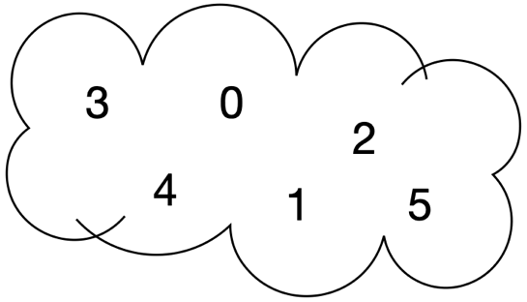
Figure 1. A cloud with the numerals 0, 1, 2, 3, 4, 5.
Ms L then asked if anyone could identify 2 numbers in the cloud that add together to make 6. One student quickly answered 4 and 2. Ms L then asked if anyone had a different answer. Another student responded 1 and 5, and the other students indicated that they agreed.
Ms L asked if anyone could identify 2 numbers in the cloud that add together to make 2. One student answered 0 and 2. Again, Ms L asked if anyone had a different answer. This time the students thought a little longer before stating that no other answers were possible.
The following is a transcript from the classroom discussion:
Ms L: How do you know?
Student: [Thinking …]
Two is only a small number, so you can’t use 3, 4 or 5.
Ms L: [Crosses out 3, 4 and 5]
Student: If you use 2, you must use 0.
If you don’t use 2, … 0 and 1 are too small.
The student reasons about the relationships between the numbers. ‘Two is only a small number’, so if you are adding together whole numbers chosen from 0 to 5, they cannot be bigger than 2.
Ms L: On your desks are 6 sticky notes. I want you to write each of the numbers from the cloud on the sticky notes.
You have 6 sticky notes but you only need the numbers to 5. What is the reason?
Student: Because zero is a number that you have. Zero counts as a number.

What is in the envelopes?
The teacher shows the students a set of small digit cards 0 to 5 and allows the students to identify that these are the same as the numbers in the cloud.
Ms L puts a pair of the digit cards into each of 3 envelopes without letting the students know which numbers are on the cards.
The teacher checks the cards in each envelope before sealing it and writing the total of the 2 cards on the front.
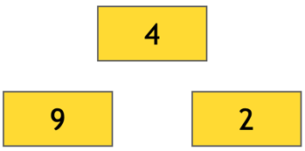
Figure 2. Boxes representing the envelopes with 9, 4 and 2.

Ms L: On your desks I have placed 3 envelopes the same as those I just made.
Each envelope contains 2 different digit cards inside, 0 to 5, with the total written on the envelope.
Using your sticky notes, can you work out which numbers must be inside each envelope? I want you to work in pairs.
Some students are uncertain of how to start.
Ms L: Two numbers together that add up to the total on the front.
It is your job to work out which numbers are inside those envelopes.
Think about what you know about numbers and how they go together.
Student: It could be 2 there or 2 there … [Lots of discussion]
Ms L: [Walks around the room and finds a pair of students who are yet to start]
What number do you want to start with?
Which number do you think is easiest to start with?
Student: [Indicates 2]
Ms L: Can you tell me 2 numbers that add together to make 2?
Student: One and one.
Ms L: Yes, but you only have one 1 there.
Student: Zero and 2. [Places the sticky notes with 2 and 0 on the envelope showing 2.]
Ms L: Which one next? Do you want to choose the 9 or the 4?
Student: 9
Ms L: What goes to make 9?
Student: [Makes 9 on her fingers.] 4 and 5 [Reading the finger pattern].
All of the students place pairs of sticky notes on the envelopes at their tables. When they are asked to check with other teams, they find the answers are the same.
Checking against the numbers in the envelopes produces widespread celebration.
For the next mystery envelopes challenge, the students work in groups of 4.
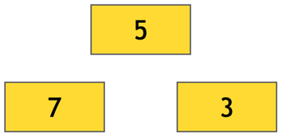
Figure 3. Boxes representing the envelopes with 7, 5 and 3.
The students quickly set to work and begin to find an answer to the problem.
Some groups look pleased that they have the answer. However, in one group the discussion is ongoing:
Student 1: I know, 5 and 0.
Student 2: It can be, but it doesn’t have to be!
It could be 4 and 1.
Student 3: But if you use 4 there, how do you make 7?
Student 2: You could use 2 and 5 for 7, couldn’t you?
The students continued discussing until they had 2 distinct solutions to the problem.
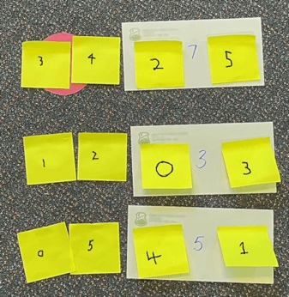
Figure 4. Sticky notes showing two solutions.
In the class discussion that followed, it was agreed that there were 2 possible answers to what was in the envelopes.
In reasoning about pairs of numbers that form specific totals, these students found that the problem conditions admit 2 distinct solutions.

Working with number properties in a Stage 2 classroom
The following example of the Working mathematically processes of understanding, communicating reasoning and problem solving links to the Additive relations outcome: completes number sentences involving addition and subtraction by finding missing values MA2-AR-02.
As students learn how to separate and combine numbers for addition and subtraction, they also develop an understanding of properties of numbers. For example, switching the position of a pair of numbers in an addition doesn’t change the total (the commutative property). That is, $16 + 14$ has the same total as $14 + 16$. Changing the order in which 3 numbers are grouped in an addition also leaves the total unchanged (the associative property).
In Stage 2, students learn to reason about the different relationships a number has to its parts (part-part-whole). For example, developing an understanding that 6 can be formed in different ways (number bonds) $6 + 0$, $5 + 1$, $4 + 2$, $3 + 3$. Students reason about these relationships when solving problems.
The following example is from a lesson on number combinations that uses Robert Kaplinsky’s ‘make it equal’ problem from his range of Open Middle problems. The problem provides students with an opportunity to explore the commutative and associative properties of addition.
Students first worked as a whole class to make both sides of a number sentence equal to 20.
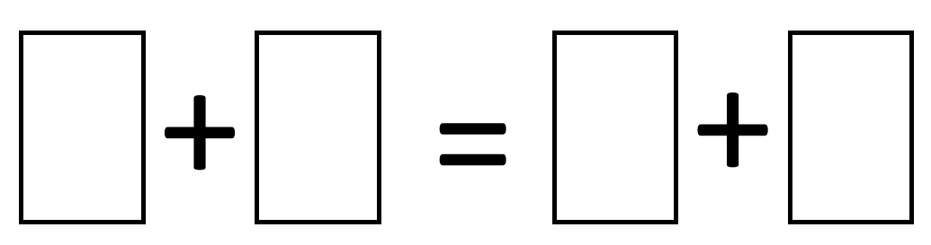
Figure 5. Number sentence with addition.
They represented each side of the number sentence using interlocking cubes and gave reasons why the numbers they chose made the 2 sides equal. For example, $10 + 10 = 9 + 11$.
Students then worked in pairs to solve the open middle task:
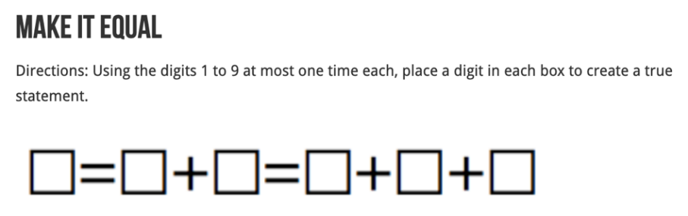
Figure 6. Make it equal.

To support students, some were provided with numeral cards for the numbers 1 to 9 to help ensure they did not repeat any numbers. Students reasoned about the number relations by saying things like:
- ‘the first number can’t be one as all the other numbers are bigger’
- ‘the first number can’t be 5 as there are not enough small numbers to make 5’
- ‘we tried the biggest number in the first box and that worked’.
Students explored how many solutions they could find. They soon realised they could make a new solution by just swapping the second and third number around ‘we had $2 + 7$ and just swapped it to $7 + 2$ because it still equals 9.
Below is a collective representation of the solutions the Year 3–4 class found for the problem:
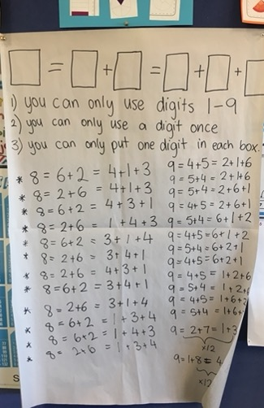
Figure 7. Solutions using digits 1 to 9.

Where to next: Constant difference
A similar investigation can be used with the constant difference property.
Using digits 1 to 9, make both sides of the following number sentence equal to 3.
Figure 8. Number sentence using subtraction.
A question like Make it equal using subtraction can highlight that unlike addition, subtraction is not commutative.
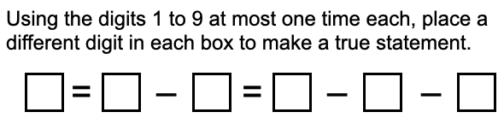
Figure 9. Subtraction problem focusing on equality

Using an area model in a Stage 3 classroom
The following example of the Working mathematically processes of understanding and fluency link to the Multiplicative relations outcome: selects and applies appropriate strategies to solve multiplication and division problems MA3-MR-01.
When students have learnt to use the structure of units to calculate the area of a rectangle, they have the basis of a powerful mathematical model. The area model can be used to show the partial products involved in multiplication.
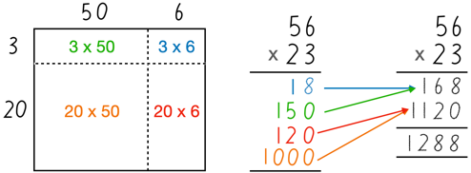
Figure 10. The area model with multiplication.
The area model can also represent products involving fractions as well as algebraic products in high school.
Realising that one method of representing a problem can be used across different types of problems is an essential component of learning to work mathematically.

Establishing the model
Using a common representation, such as subdividing area, can assist students to appreciate the utility of a mathematical model. In the following problem involving the squares of 2-digit numbers ending in 5, the solution procedure is derived from the representation.
In a Stage 3 class, students had worked on sub-dividing rectangles and linking the areas with 2-digit by 2-digit multiplication. For example, they represented the area corresponding to $25 × 15$ using the following diagram.
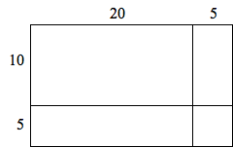
25 × 15
Figure 11. Representing area by subdividing.
When they had become familiar with drawing rectangles to represent multiplication of 2-digit numbers the class investigated a special number pattern.

Determining a pattern in a Stage 3 classroom
The following example of the Working mathematically processes of understanding, fluency and communicating reasoning link to the Multiplicative relations outcome: selects and applies appropriate strategies to solve multiplication and division problems MA3-MR-01, and to the Two-dimensional spatial structure outcome: selects and uses the appropriate unit to calculate areas, including areas of rectangles MA3-2DS-02.
To begin the lesson, the students were asked to calculate the squares of all 2-digit numbers ending in 5. Their answers were recorded and the students then searched for patterns in the answers.
The first pattern recognised by the students showed that not only did all the answers end in 5, they all ended in 25. The teacher then encouraged the students to look for a pattern that could be used to find the square of a 2-digit number ending in 5. Knowing the final 2 digits was helpful, could they find a way to determine the other digits in the answer?
The students discussed this in pairs but could not see a clear pattern.
Eventually, one student said that if you looked at $35 × 35$, then $3 × 3 = 9$ and 3 more makes 12, which are the 2 digits in front of the ‘25’.
The teacher commented that she thought this could be helpful and asked if there was another way to say this. After several attempts, one student restated her thinking by saying, ‘In the tens column you multiply by one more than itself’.
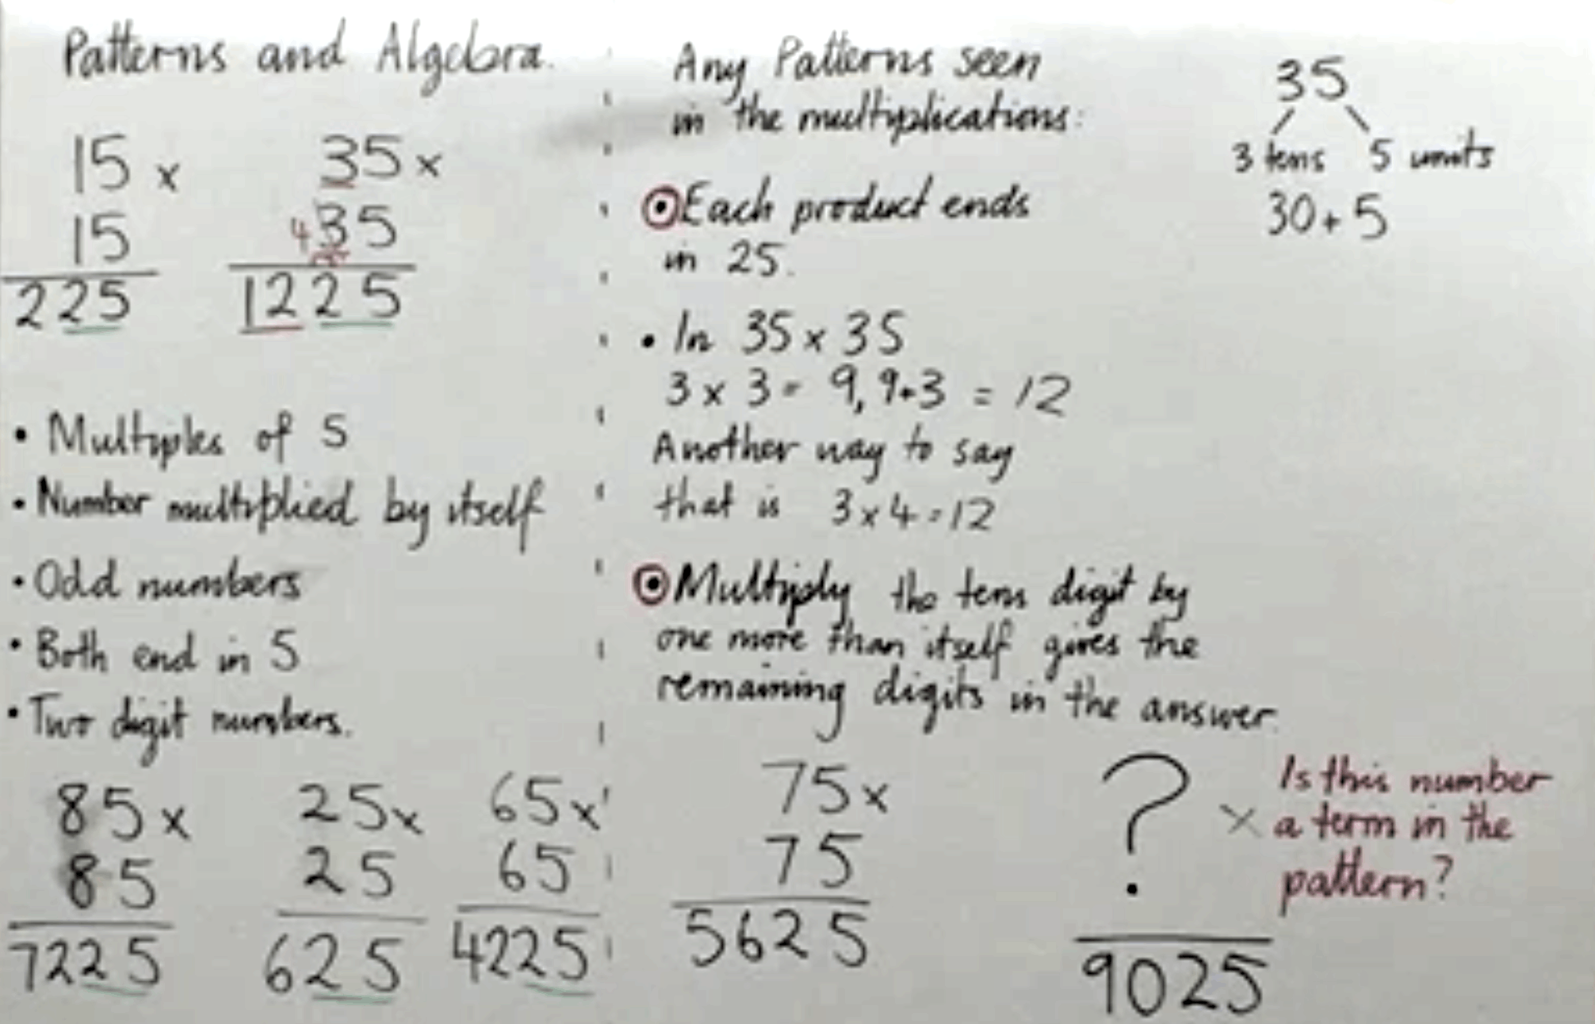
Figure 12. The board summary of the search for a pattern
The teacher summarised this as ‘Multiply the tens digit by one more than itself gives the remaining digits in the answer’. The students checked their understanding of this general rule against their answers to verify that it did describe the pattern. They also tried to reverse the process to determine if a given answer (9025) was part of the pattern.

Why does the pattern work?
The next lesson engaged the students in trying to explain why the pattern worked.
Working in pairs with each group using a large piece of paper, students were asked to start with an example such as $35×35$ to determine where the pattern came from.
The students recorded various ideas that occurred to them on their paper.
The teacher noticed that one group had drawn a square and started to subdivide the sides into lengths of 30 cm and 5 cm but then appeared to be stuck. To encourage others to engage with the area model the teacher asked this group to share their thinking with the class.
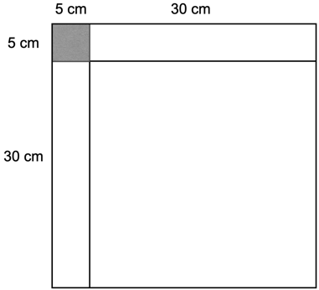
Figure 13. An area model showing the problem
The students could see that the small 5 cm by 5 cm square in this diagram would have an area of 25 square units. However, the second part of the pattern, multiplying the digit in the tens column by one more than itself, remained a mystery.
The teacher encouraged the students to take a new piece of paper and draw a square representing 35 $×$ 35. They then subdivided the square and started to think about how the parts could be rearranged.
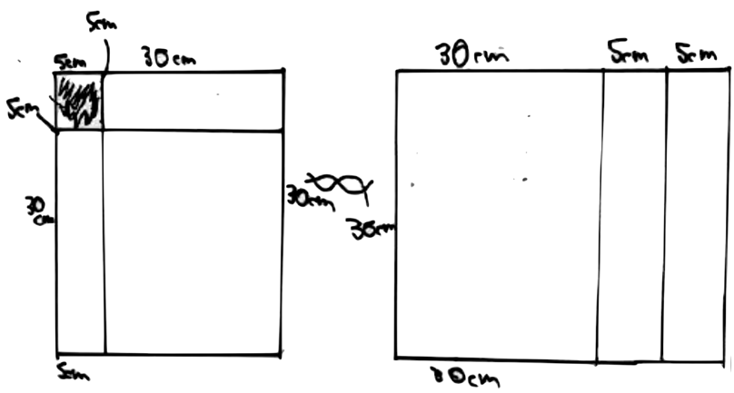
Figure 15. Students’ drawings of how they subdivided the square
One group described how they tried to move the 30 cm by 5 cm rectangles to different places before they settled on the arrangement shown above. This produced a 30 cm by 40 cm rectangle. After a little more discussion, one of the students realised that the same result could be achieved with only moving one rectangle, rather than 2.

Generalising the explanation
The students were challenged to use an example other than $35 × 35$ and rearrange the parts to explain why the pattern worked.
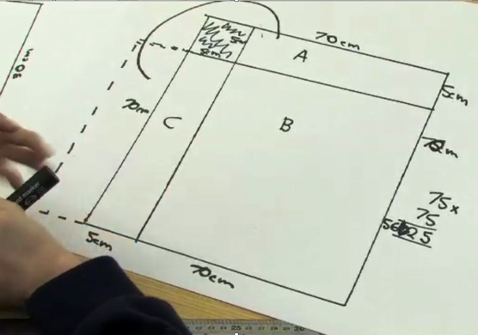
Figure 16. Showing 75 × 75 is 25 + 70 × 80
At the conclusion of the lesson the students were asked to draw a diagram and write an explanation of why the square of a 2-digit number ending in 5 could be found using this pattern.
In the above example, Working mathematically started with students identifying a pattern in the digits in the squares of 2-digit numbers ending in 5. With guidance and carefully sequenced teaching activities, the students developed a logical explanation for the pattern by subdividing and rearranging parts of an area model. They then communicated their reasoning in writing.

Cuoco A, Goldenberg EP and Mark J (2010) ‘Contemporary Curriculum Issues: Organizing a Curriculum around Mathematical Habits of Mind’, The Mathematics Teacher MT, 103(9):682–688, doi:10.5951/MT.103.9.0682.
– National Research Council (2001) Adding it up: Helping children learn mathematics, Kilpatrick J, Swafford J, and Findell B (eds), National Academy Press, Washington DC, doi:10.17226/9822.
– Fonger NL (2019) ‘Meaningfulness in representational fluency: An analytic lens for students’ creations, interpretations, and connections’, The Journal of Mathematical Behavior, 54:1–26, doi:10.1016/j.jmathb.2018.10.003.
– Watson A and Sullivan P (2008) ‘Teachers learning about tasks and lessons’, in Tirosh D and Wood T (eds) Tools and processes in mathematics teacher education, Sense Publishers, Rotterdam, Netherlands.
– National Research Council (2001) Adding it up: Helping children learn mathematics, Kilpatrick J, Swafford J, and Findell B (eds), National Academy Press, Washington DC, doi:10.17226/9822
– Nunes T, Bryant P, Evans D, Bell D, Gardner S, Gardner A, and Carraher JN (2007) ‘The contribution of logical reasoning to the learning of mathematics in primary school’, British Journal of Developmental Psychology, 25:147–166, doi:10.1348/026151006X153127.
– Kaplinsky describes ‘open middle’ problems as having multiple ways to approach and ultimately solve the problem. The open middle problems using in this example are from https://www.openmiddle.com/

